Predictive analytics assignment

Topic: Create a chat-bot on google dailogflow.

Introduction: A chat bot is a computer program that simulates human conversation through voice commands or text chats or both. Chat bot, short for chatterbot, is an Artificial Intelligence (AI) feature that can be embedded and used through any major messaging application.

There are a number of synonyms for chat bot, including "talkbot," "bot," "IM bot," "interactive agent" or "artificial conversation entity."

Objective: This chatbot is created to assist people to explore Hyderabad in food, weekend trips, temples, adventurous parks. We ca refer this chat bot as Mr. Mia Bhai. This chat bot is created on “google dialog flow”.

Methodology:

* **Level 1 – Getting Started**
* **Level 2 – Bot Development**
* **Level 3 – Entities, Actions & Parameters**
* **Level 4 – Integration**
* **Level 5 – Training & Fall backs**

Screen shots:

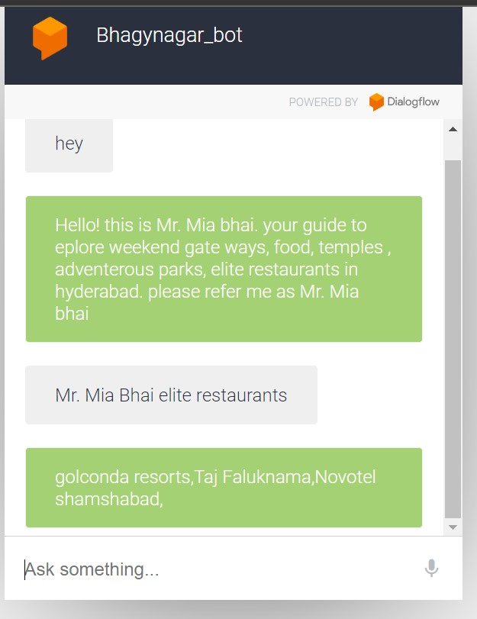

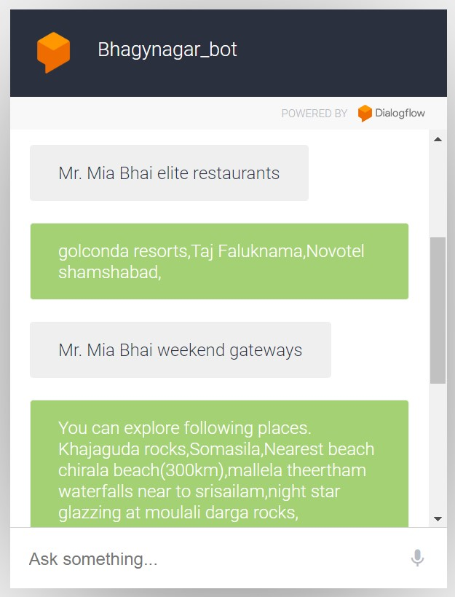

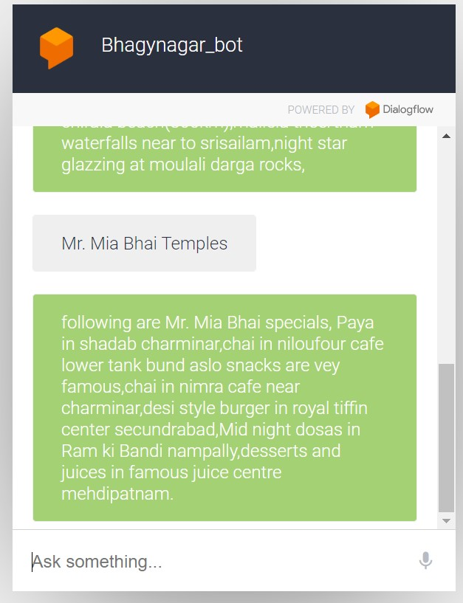

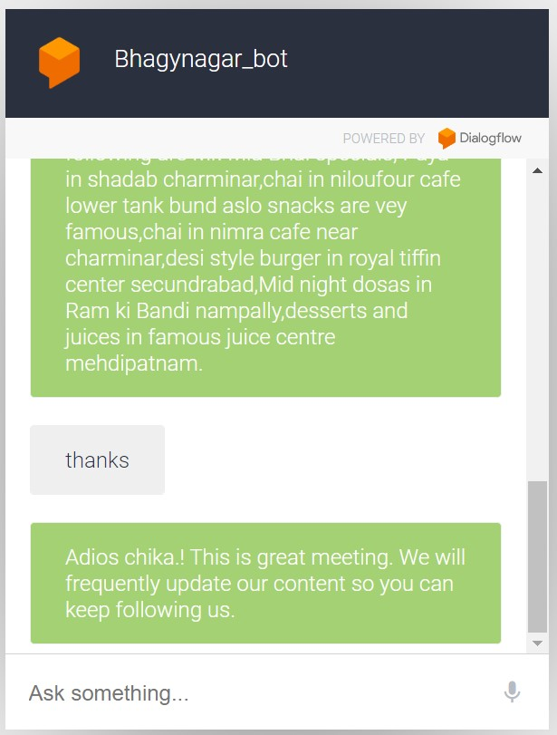

You can have a conversation with MR. Mia Bhai about exploring Hyderabad using the following chat bot link: <https://bot.dialogflow.com/f91c04ca-d2f7-4dbd-8a35-213498d7aab4%20>

Conclusion: Aalthough a chat bot is created this needs more accuracy and precision for real time implementation. An advanced chat bot can be created using more appropriate tools like AWS chat bot creation. More technology can be use like Virtual reality and Natural language methods and some speech prediction methods. We can also add emotional touch to the chat bot that gives more support to the customer.

Submitted by

K Bala Venkat Sai

21mbmb28